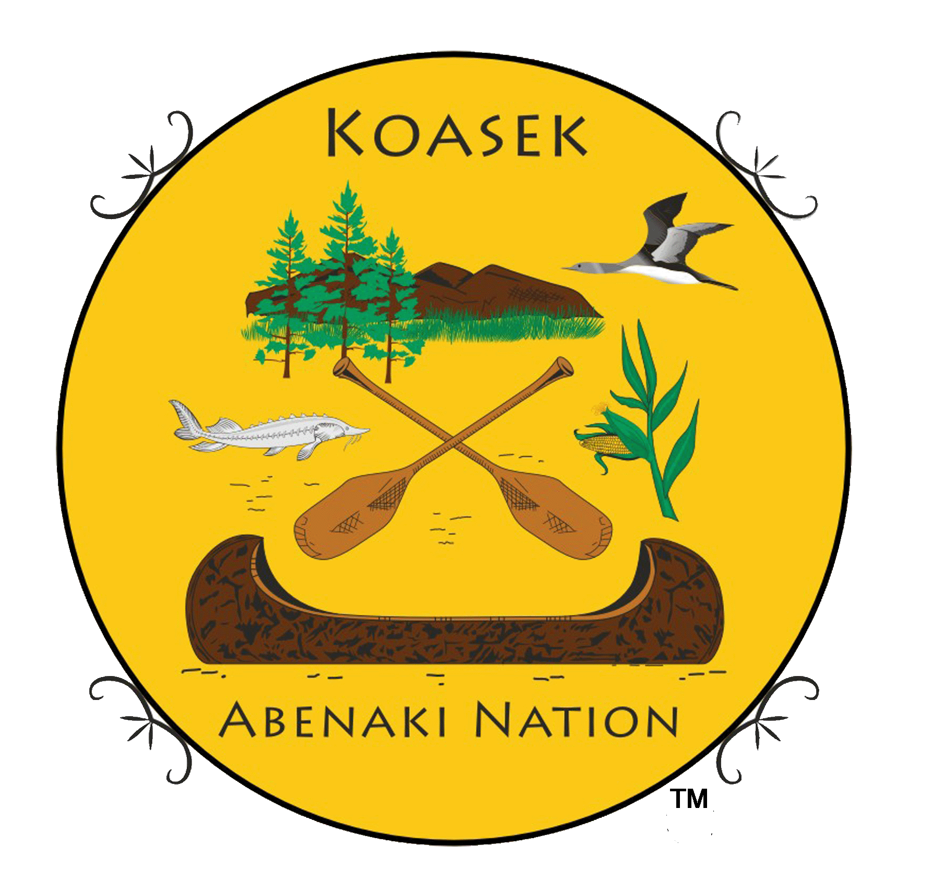
Koasek W8bnaki Nation
Formerly
Ko’asek (Co’wasuck) Traditional Band of the Sovereign Abenaki Nation
Traditional Territory of New England & Eastern Canada
Koasek of Turtle Island, Inc. (501/c3
“Preserving and restoring our native culture, while walking in peace with nature.”
http://koasekabenakination.com/ https://www.facebook.com/CowasuckAbenaki
Nation Genealogist, Tribal & War Chief & Chief & Elder Paul J. Bunnell, UE Bunnellloyalist@aol.com
Archives & Records Center 49 Pleasant St., #106, Alstead, NH 03602
^^^^^^^^^^^^^^^^^^^^^^^^^^^^^^^^^^^^^^^^^^^^^^^^^^^^^^^^^^^^^^^^^^^
Tribal Council & Region Elder’s Council & Region
Rick Herrin – NH Terri Helms – KS
Justin Deth – VT Ruth Descoteaux – VT
Dr. Theresa Styles – GA (Website Master) Chief Paul Bunnell – NH
Sheila Williams – NH Lori Rankin – NS - Canada
Jeannine Dwyer – OR Dan Osgood Sr. – NH (Reserve)
Jacob Waters – MN
Acting Security Chief – Chief/Elder Paul Bunnell – NH
^^^^^^^^^^^^^^^^^^^^^^^^^^^^^^^^^^^^^^^^^^^^^^^^^^^^^^^^^^^^^^^^
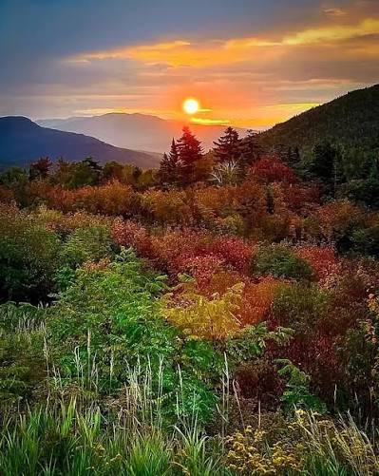
White Mountain Dawnland Sunrise
2027 Koasek Election

Kwai All Koasek Members,
This will be our 4th organized election that has been held every 7 years. We have all been faced with many challenges, and received many gracious gifts that has made us stronger and richer. You should all be proud for protecting our culture and Koasek heritage.
350 years ago, in 1676, the Koasek (Cowasuck) Abenaki people were navigating the devastating realities of King Philip’s War (1675–1676), which forever altered our ancestral homeland (Ndakinna) along the upper Connecticut River valley of Vermont and New Hampshire.

We have a proud history that is still here today so your vote in our democratic elections are very important. I hope you can meet all the election committee members who will be helping you get your votes turned in for our May 2027 election results.

We will have 9 stages of our election process.
- We have an election committee and they are; Chief/Elder Paul Bunnell (Temp position), of NH, Shirley Sprague of VT., Mary Beth Doonan of Mass, Vincent and Jennifer Keane of NY, Tricia O’Connell of Kansas City, Mo., and Lori Rankin of Nova Scotia Canada.
- ALL UPDATED ARTICLES AND DOCUMENTS WILL BE POSTED AT OUR WEBSITE FOR YOU TO READ. YOU THEN MAKE YOUR VOTE ON YOUR BALLOT, YES or NO. Location at our website will be under 2027 Voting Articles. https://koasekabenakination.com/
- A request to submit nominations for positions, either a self nomination or nomination of another. (all nomination will be approved by the candidate before entering on the ballot) (And reviewed by the committee and possibly elders).
- Deadline for nominations is 1 December 2026
- Enter all names and articles on ballot. Only one vote for Chief, and Sub-Chief, and up to 10 votes for Council Members. Completed ballots will be emailed or mailed out for you to vote. (nominated chief’s must have an elder, chief, or council member, or clan mother/leader to sign as sponsorship).
- Deadline to return your votes is 1 April 2027. (Election committee will be contacting you for your votes during this time)
- Election results on 1 May 2027 (Saturday) (possibly on our Elm St. land)
- Election Feast and Chief oath of office on 2 May 2027 (Sunday) (Possibly on Elm St land)
- Provide a locked box for ballots and file for no less then 2 years.

PLEASE BE SURE TO VOTE. ANYONE OVER 15 CAN VOTE.

Regards,
Chief/Elder Paul “Gwilawato” Bunnell

