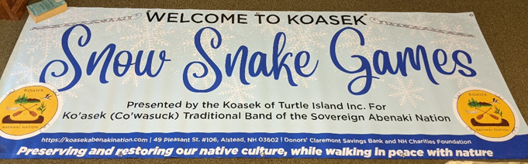
11th Snow Snake Games, Millot Green, Alstead, New Hampshire
Ko'asek (Co'wasuck)Traditional Band of the Sovereign Abenaki Nation
https://koasekabenakination.com/
1 Feb. 2025 10 AM to 2:30 PM
No Snow Day
8 Feb 2025 10 AM to 2 PM
Town Hall at the Alstead Fire Dept.
Pot luck & prizes for snake snakes, drums, songs, storytelling, etc.

The committee meeting for 23 Oct 2025 7 PM Zoom
ALL WELCOME
Meeting Attendee: Chief Paul,

Attending:

Please start planning now.

We Need the Following:
- Fire Keeper
- Security – War Chief David
- Volunteers to serve hot drinks/snacks at Gazebo
- Helping monitors for snake instructions at runs
- Songs, drums,
- Story Tellers
- Volunteers for Runs (placing snakes after throws)
- Advertising
- School visits
- Run builders the day before and during (Very important. Need many volunteers) Bring shovels
- Wood for fire
- Seek donors from banks and businesses and the public. Draft letters/emails

Please Volunteer and help plan another successful event. SIGN UP NOW.

An Alcohol & Drug Free Event

Our Generous Donors – Let’s ask them again for donations

New Hampshire Charitable Foundation, Concord, NH
Springfield Vermont Food Co-op- Springfield VT
Sullivan County Conservation District, 95 County Farm Rd. Unity, NH 03743
Fidelity Charities, Albuquerque NH
Claremont Spice & Dry Goods, 12 Tremont St, Claremont, NH 03743
Grant Award from Maine Community Foundation, 245 Main St., Ellsworth, ME 04605
Henry and Helen Cormier Fund for Claremont, Special Projects Grantmaking Fund, Wellborn Ecology Fund
Morgan Hill Mount Cabot Maple, 69 Rowell Road, Lancaster, NH 03584
Quaker City Friends, Unity, NH
Orchard Hill Quaker (Friends), Alstead, NH
Alstead, NH Koasek Pow Wow 11-12 June 2022
Claremont Savings Bank, Claremont, NH
Community Village, Earth Roots Group
Mascoma Bank, Claremont NH
Hypertherm HOPE Foundation, Hanover, NH
Savings Bank of Walpole NH, Walpole, NH
Anonymous Donor, NH
Northern Lights Federal Credit Union, Langdon, NH
Adrianne McLaramore, Royal Oak, Michigan
The Orchard School and Community Center, Alstead, NH
Gathering Waters Chartered Public Schools (4th Grade), Keene, NH
Orchard Hill Breadworks, Alstead, NH
Town of Alstead, NH
Susan Taylor & Friends

Contact: Ko'asek (Co'wasuck)Traditional Band of the Sovereign Abenaki Nation.
49 Pleasant St. #106, Alstead, NH 03602, Bunnellloyalist@aol.com

ZOOM Call in & Password
Join Zoom Meeting
https://us02web.zoom.us/j/6559869212?pwd=dzNqUjNnMktUeWRyNlBudmtCcDBTUT09
Meeting ID: 655 986 9212
Passcode: abenaki

