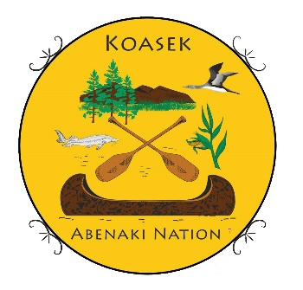

2024 Nov.
Our Appreciation and thank you goes to our friends and supporters at Mascoma Bank for their $1500 grant donation for our upcoming 31 May-1 June 2025 Pow Wow in Alstead, NH. With this donation it helps us cover the cost for all of our cultural events for this special weekend and that provides it free for all. Our community outreach programs are here thanks to supporters like Mascoma Bank.
Great Blessings, Chief Paul Bunnell
Koasek of Turtle Island Inc.
Ko'asek (Co'wasuck)Traditional Band of the Sovereign Abenaki Nation
https://koasekabenakination.com/

